2. The answer is 19. We’ll first show that the shortest path cannot be either 17 or 18. If it is 17 then every edge is covered exactly once. In this situation, every vertex must have even degree except for the starting and end point. However, there are 6 vertices in the graph with odd degree – a conflict. If the shortest path is 18, then there is exactly one edge that is repeated and only repeated once. By replicating one edge in the graph, there will still be at least 4 vertices in the graph with odd degree. And by replicating, the 18 edges are covered exactly once. But this is impossible based on the same reasoning. Now we list one path with shortest path 19.

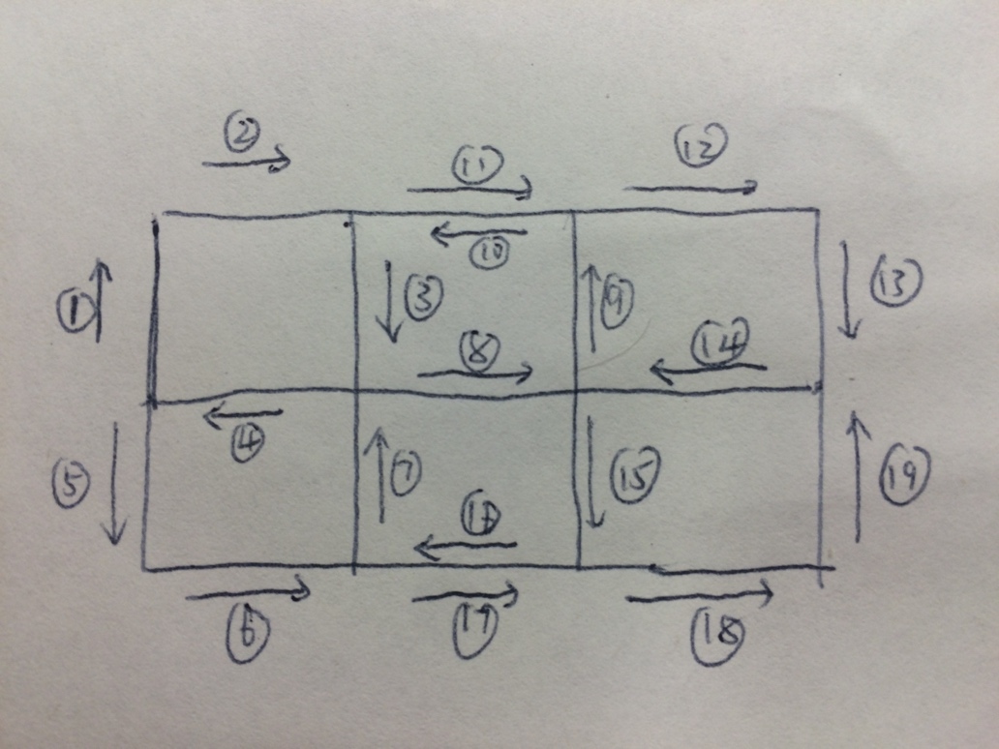

5. The solution is the same as it is in problem 43 The Broken Bar in the book Fifty Challenging Problems in Probability and Solutions.

8. We only have to generate numbers 0-(n-1) with equal probability. Let 2^k <= n-1 < 2^{k+1}, we toss the coin k times and use the result to make a k bit binary number (head as 1, tail as 0). If the number is >= n, discard this number and generate again until we have some number <n. This random number generator can produce numbers from 0 to n-1 with equal probability 1/n.

18. Analysis and code for this problem can be found at <http://blog.csdn.net/skyworth0103/article/details/38472639>. The problem is about how to construct Hamiltonian cycle given ORE condition (which is a sufficient condition on the existence of Hamiltonian cycle).